16.mmWave Loss Components (28 GHz & 60 GHz)

1. AIM
To calculate and compare mmWave path loss components at 28 GHz and 60 GHz using a basic free-space model in MATLAB.

2. SOFTWARE REQUIRED
- MATLAB (any version 2015+)
- No extra toolboxes needed

3. THEORY (Simple)
Why mmWave?
Millimeter-wave bands (28 GHz, 60 GHz) are used in 5G for high data rates but suffer from high propagation loss.

Key Loss Components
1. Free Space Path Loss (FSPL)
$$FSPL(dB)=32.44+20{log⁡}_{10}(f_{MHz})+20{log⁡}_{10}(d_{km})$$
2. Atmospheric Absorption
- At 28 GHz → low absorption
- At 60 GHz → very high absorption due to oxygen peak (~15 dB/km)
3. Rain/Fog Loss (simplified)
- Increases with frequency
- Heavy rain: 10–20 dB/km at mmWave
4. PROCEDURE (Simple)
- Choose frequencies: 28 GHz, 60 GHz
- Choose a distance range: 1 m to 1000 m
- Convert distance to km and frequency to MHz
- Apply FSPL formula
- Add atmospheric absorption (constant per km)
- Plot both curves
- Compare losses

5. PSEUDOCODE
Set frequency1 = 28 GHz
Set frequency2 = 60 GHz
Create distance vector d = 1 to 1000 m
Convert distances to km
Compute FSPL for both frequencies
Add atmospheric absorption (0.5 dB/km for 28 GHz, 15 dB/km for 60 GHz)
Plot results
CODE
clear; clc; close all;

%% PARAMETERS
frequencies = [28e9 60e9]; % Frequencies in Hz
c = 3e8; % Speed of light (m/s)
distances = 1:1:100; % Distance in meters
epsilon_r_wall = 5; % Relative permittivity of wall
theta_inc = 45; % Incident angle in degrees

% Atmospheric attenuation (dB/m)
atm_loss = [0.06, 0.2]; % 28GHz, 60GHz

%% INITIALIZE ARRAYS
ReflectionLoss = zeros(length(frequencies), length(distances));
PenetrationLoss = zeros(length(frequencies), length(distances));
AtmosphericLoss = zeros(length(frequencies), length(distances));

%% COMPUTE LOS / LOS COMPONENTS
for f_idx = 1:length(frequencies)
f = frequencies(f_idx);

for d_idx = 1:length(distances)
d = distances(d_idx);

% -------- Reflection Loss (Fresnel coefficient, perpendicular polarization) --------
theta_rad = deg2rad(theta_inc);
gamma = (cos(theta_rad) - sqrt(epsilon_r_wall - sin(theta_rad)^2)) / ...
(cos(theta_rad) + sqrt(epsilon_r_wall - sin(theta_rad)^2));
ReflectionLoss(f_idx,d_idx) = abs(gamma)^2; % Power reflection coefficient
ReflectionLoss(f_idx,d_idx) = -10*log10(ReflectionLoss(f_idx,d_idx)+eps); % dB

% -------- Penetration Loss (frequency-dependent) --------
PenetrationLoss(f_idx,d_idx) = 5 + 0.02*f/1e9; % Example: 28GHz ~5.56dB, 60GHz ~6.2dB

% -------- Atmospheric Loss (linear with distance) --------
AtmosphericLoss(f_idx,d_idx) = atm_loss(f_idx) * d; % dB
end
end

%% -------------------- PLOTS --------------------
figure;

% Reflection Loss
plot(distances, ReflectionLoss(1,:),'r','LineWidth',1.5); hold on;
plot(distances, ReflectionLoss(2,:),'b','LineWidth',1.5);

% Penetration Loss
plot(distances, PenetrationLoss(1,:),'r--','LineWidth',1.5);
plot(distances, PenetrationLoss(2,:),'b--','LineWidth',1.5);

% Atmospheric Loss
plot(distances, AtmosphericLoss(1,:),'r-.','LineWidth',1.5);
plot(distances, AtmosphericLoss(2,:),'b-.','LineWidth',1.5);

grid on;
xlabel('Distance (m)'); ylabel('Loss (dB)');
title('mmWave Loss Components at 28 GHz and 60 GHz');
legend('Reflection 28 GHz','Reflection 60 GHz', ...
'Penetration 28 GHz','Penetration 60 GHz', ...
'Atmospheric 28 GHz','Atmospheric 60 GHz');

OUTPUT:

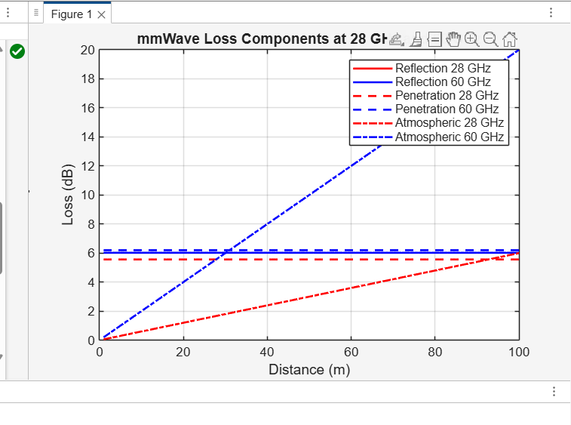
RESULT:
- At the same distance, 60 GHz has much higher total loss than 28 GHz.
- This is due to higher free-space loss and strong oxygen absorption (~15 dB/km) at 60 GHz.
- Therefore, 28 GHz is suitable for longer-range 5G, while 60 GHz is better for short-range high-capacity links.

